

Distributed Data Pipelines
2025 Apr Semester

SCHOOL OF INFOCOMM TECHNOLOGY
Diploma in Data Science

INDIVIDUAL ASSIGNMENT
(40% of Distributed Data Pipelines Module)
Released on 30 Jun 2025

DEADLINE FOR SUBMISSION
02 Aug 2025 (Saturday), 2359 Hours
Student Name | : | SIMON SAW YONG PING
Student Number | : | S10267332J

- Problem Statement Formulation
Back in primary school, I would have to take long rides from school to home and my parents would be anxious whether I was capable of going home alone. From self-experience, students of primary school and their parents frequently face uncertainty when planning their daily commute due to a lack of real-time, child-friendly bus arrival information at bus stop code 01121. Located directly outside the school, this bus stop serves as a key pickup and drop-off point during peak school hours.
Parents often struggle with last minute decisions on whether to accompany their children to the bus stop or let them wait alone. Inconsistent or unclear arrival timings can lead to long waiting periods under harsh weather conditions or missed buses—both of which can be distressing for young students. Moreover, current bus transport apps such as SG Buses may present data in a format that is cluttered, slow to refresh, or difficult for children to interpret. Being a user of the bus app SG Buses, I felt that the app had too many advertisement pop-ups which made me feel annoyed as I had to watch a full 2 minute advertisement in order to use the app to track the bus timings.
In order to solve this problem, this solution aims to develop a real-time bus arrival monitoring system using LTA DataMall’s Bus Arrival API. Since we live in the age of technology, I realised that a lot of parents have entrusted their children with a smartphone which will allow them to use the application outside.
This programme will allow students and parents to easily access accurate, up-to-date bus arrival information for bus stop 01121. The interface and data presentation will be optimised for quick understanding and daily use, helping parents make timely decisions and giving students a more reliable commuting experience.
Ultimately, this programme hopes to enhance commuter safety, increase convenience, and empower families with data-driven decisions, thus promoting smarter and more confident travel for the school community.
- Preparation
2.1Bus Arrival
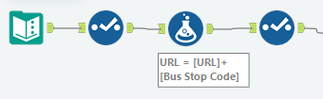
In this stage, I prepared my Alteryx workflow to dynamically retrieve real-time bus arrival information based on user input of a bus stop code which in this case is 01121.
For my first API(Bus Arrival), I started by using a Text Input tool to store the bus stop code 01121 and base URL (https://datamall2.mytransport.sg/ltaodataservice/v3/BusArrival?BusStopCode=) and User-Agent (Mozilla).
Next, a Select tool was used to view the number of fields available from the input. This step allowed me to observe how many fields were present in the input and ensured that I was only passing relevant values to the API generation stage. Cleaning up early-stage data helps maintain a lean and organized workflow, which is especially useful when scaling or debugging.
Next step is to use the Formula tool. I entered this formula “[URL]+[Bus Stop Code]” to get a URL from the previous input which concatenates the base URL and bus stop code 01121 to get the specifics.
After generating the complete API URL, I introduced another Select tool. This time, the goal was to trim off any redundant or placeholder fields that were carried over from the earlier inputs. Removing these unnecessary fields ensures that the downstream API call remains clean and readable. It also makes the dataset more manageable and avoids confusion when referencing specific columns.

2.2Bus Stop
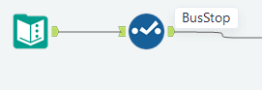
In this stage, I prepared my Alteryx workflow to dynamically retrieve train alerts to check whether certain MRT lines were disrupted. For my third API(Train Service), I started by using a Text Input tool to store base URL (https://datamall2.mytransport.sg/ltaodataservice/BusStops) and User-Agent (Mozilla).
The User-Agent is a mandatory header field used by the LTA DataMall system to identify the requesting client and ensure the API calls are valid and secure. Omitting this field may result in failed API requests or access denial, so including it upfront was a crucial step in ensuring successful communication with the server.

Next, I used a Select tool to examine the available fields from the input. This allowed me to identify which fields were necessary for the API generation and remove any that were irrelevant. Performing this cleanup early in the workflow helps keep the process streamlined and organized, which is particularly important when scaling the solution or troubleshooting issues later on.

2.3Train Service Alert
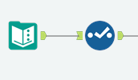
In this stage, I prepared my Alteryx workflow to dynamically retrieve static information about train service alerts, such as active disruptions and affected lines across Singapore’s MRT network. This was done using the Train Service Alerts API, which provides timely updates on any service-related issues impacting rail operations. This API complements the bus-related APIs by offering commuters a broader view of public transport availability and conditions in real time, enhancing situational awareness and journey planning.
For my third API (Train Service), I began by configuring a Text Input tool to store the base URL (https://datamall2.mytransport.sg/ltaodataservice/TrainServiceAlerts) and the User-Agent (Mozilla). The User-Agent is a mandatory header field used by the LTA DataMall system to identify the requesting client and ensure API calls are recognized as valid. Without this field, requests may be rejected or ignored, so including it at this stage ensures secure and successful data retrieval.
Next, a Select tool was used to inspect the number of fields passed in from the input. This validation step helped confirm that the URL and all required headers were properly structured. Additionally, I used the Select tool to remove any redundant or placeholder columns, keeping the input clean and focused. Performing this cleanup early enhances workflow clarity and minimizes the risk of formatting errors in the upcoming API request stage.

At this stage, it was important to verify that all required fields ,especially the URL and headers , were present and correctly formatted. I made sure the data contained valid entries and that no nulls or mismatches existed before passing it to the Download tool in the next phase. Overall, this preparation phase set up the core infrastructure for API connectivity, including variable handling, dynamic URL generation, header configuration, and data validation. It laid the groundwork for the next stages involving the actual API call and parsing of the returned JSON data.

- API Call
3.1 Bus Arrival
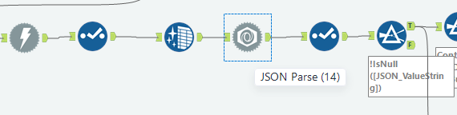
- Download Tool
For the first API (Bus Arrival), I used the Download tool to send an HTTP request to the LTA DataMall endpoint. I included the required AccountKey for authentication, as well as the User-Agent header, which is mandatory for all API calls. The User-Agent tells the server who is making the request. I checked the “User-Agent” option to ensure the request included a valid value (e.g., Mozilla). Without these headers, the server may reject or ignore the request. Including them ensured the API call was processed correctly and the data returned as expected.
- Select Tool
After the download, I used the Select tool to choose only the necessary fields: Bus Stop Code and DownloadData. These are critical for the next steps. I deselected fields like URL, User-Agent, and DownloadHeaders, which are no longer needed. This helps streamline the dataset and improves processing efficiency.
- Data Cleansing Tool
I then applied a Data Cleansing tool to the DownloadData field. This cleaned up unwanted whitespace and replaced null values with blanks (for strings) or zeros (for numeric fields). This helps avoid issues when parsing or displaying the data later.
- JSON Parse Tool
Next, I used the JSON Parse tool to transform the nested JSON structure into a flat format. This created two fields: JSON_Name and JSON_ValueString , making the data easier to work with in tabular form.
- Select Tool
I used another Select tool to retain the newly parsed fields (JSON_Name and JSON_ValueString). This step cleaned up the dataset further before filtering for relevant content like service numbers and estimated arrival times.
- Filter Tool
A Filter tool was added to remove rows where JSON_ValueString was null. This ensures that only meaningful, usable data moves forward in the pipeline.

3.2Bus Stop
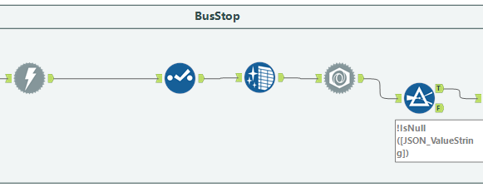
- Download Tool
The process begins with the Download tool, which sends an HTTP request to the LTA DataMall API using the URL. This tool is responsible for retrieving the raw JSON response. I included the required AccountKey for authentication, as well as the User-Agent header, which is mandatory for all API calls. The User-Agent tells the server who is making the request. I checked the “User-Agent” option to ensure the request included a valid value (Mozilla). Without these headers, the server may reject or ignore the request. Including them ensured the API call was processed correctly and the data returned as expected.
- Select Tool
Next, a Select tool is used to retain only the necessary fields from the downloaded data. Fields like DownloadData are kept for parsing, while others such as URL, User-Agent, and DownloadHeaders are removed. This step helps streamline the dataset, keeps the workflow clean, and ensures that only the relevant data is passed on to subsequent tools.
- Data Cleansing Tool
A Data Cleansing tool is then applied to clean the DownloadData field. It removes unwanted whitespace, tabs, and null characters, and replaces missing values with blanks or zeros. This ensures that the data is properly formatted and ready for parsing, reducing the risk of errors during transformation.
- JSON Parse Tool
Once the data is cleaned, it is passed into the JSON Parse tool. This tool reads the raw JSON and converts it into a structured table format by splitting it into two fields: JSON_Name, which contains the key path, and JSON_ValueString, which holds the corresponding value. This step flattens the nested JSON structure, making it easier to filter, reshape, and analyze the data.
- Filter Tool
Finally, a Filter tool is used to exclude any records where the JSON_ValueString field is null. This ensures that only valid, meaningful entries are kept, allowing the workflow to focus on usable data. Filtering out empty values helps maintain data quality and improves the accuracy of any further transformations or visualizations.

3.3Train Service Alert
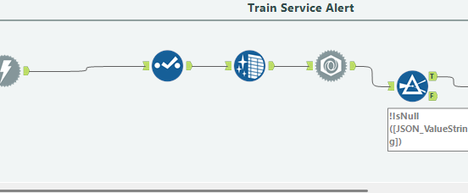
- Download Tool
The process begins with the Download tool, which sends an HTTP request to the LTA DataMall Train Service Alerts API using the constructed URL. This tool retrieves the raw JSON response that contains live updates on train service statuses. I included the required AccountKey for authentication and checked the “User-Agent” option, setting it to a valid value (e.g., Mozilla). Both headers are mandatory; without them, the server may reject or return an empty response. Including them ensures the API request is valid and processed successfully.
- Select Tool
A Select tool is used next to retain only essential fields from the downloaded data. The primary field of interest is DownloadData, which contains the full JSON response. Other fields like URL, User-Agent, and DownloadHeaders are removed to streamline the workflow and reduce clutter before parsing.
- Data Cleansing Tool
The Data Cleansing tool is applied to the DownloadData field to remove unwanted whitespace, tabs, or formatting issues and to replace any null values with blanks or zeros. This prepares the raw JSON for smooth parsing and prevents potential errors when reading or splitting the data.
- JSON Parse Tool
After cleansing, the JSON response is passed into the JSON Parse tool, which flattens the nested JSON into two columns: JSON_Name and JSON_ValueString. This allows key fields such as Line, Status, and Direction to be extracted and worked with in a tabular format.
- Filter Tool
A Filter tool is then used to remove records where the JSON_ValueString is null. This ensures that only meaningful and usable information is retained, improving data quality and simplifying downstream filtering, pivoting, and display.

4. Data Display
4.1 Bus Arrival
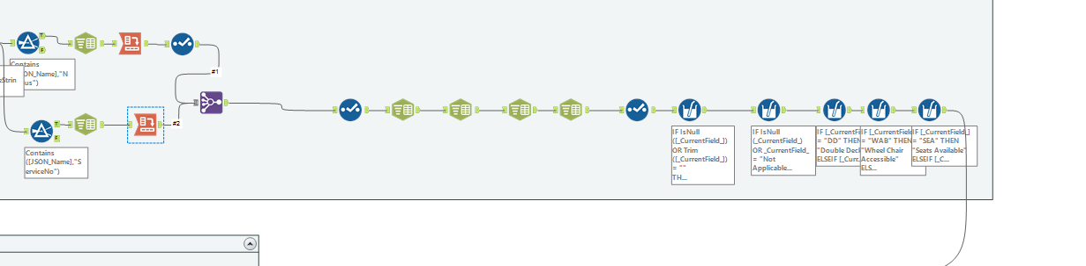
- A) Filter Tool
I used a Filter tool to keep only JSON_Name values containing "NextBus". This filters the dataset down to important attributes such as EstimatedArrival, Load, Type, and OriginCode.
B) Text to Columns Tool
I then used a Text to Columns tool to split the JSON_Name using the period (.) delimiter. For example, Services.0.NextBus.EstimatedArrival becomes four columns: Services, 0, NextBus, and EstimatedArrival. This breakdown makes filtering and transformation much easier.
C) Cross Tab Tool
I applied a Cross Tab tool to pivot the data into a readable table. I grouped by bus stop code and service index, then used the last part of the key (like EstimatedArrival, Load) as the new column headers. Values were taken from JSON_ValueString, and multiple values were combined using the Concatenate method.
D) Select Tool
After pivoting, I used a final Select tool to keep only useful fields like Bus Stop Code, EstimatedArrival, Load, Feature, and Type, and removed any extra columns to keep the output clean and readable.
- A) Filter Tool
I added a Filter tool to extract only rows where JSON_Name contains "ServiceNo". This helped link each index to a specific bus service. For example, index 0 may be bus 133, index 1 might be 145, and so on.
B) Text to Columns Tool
Another Text to Columns tool was used to split paths like Services.0.ServiceNo into three parts, making it easier to align each service number to its index.
C) Cross Tab Tool
Lastly, a Cross Tab tool was used to organize each bus index into its own row. Grouped by bus stop code and index, the fields like ServiceNo became column headers, and the bus numbers were placed accordingly. This clearly matched each bus number with its arrival details from earlier.
- Join Multiple Tool
In this step, the Join Multiple tool is used to combine data from two branches of the workflow by matching values in their respective "2" columns. This join allows the merging of bus service numbers from the left input with their associated details like estimated arrival times, features.
- Select Tool
In this step, the Select tool is used to refine the dataset by keeping only the relevant fields necessary for further analysis and display. Fields such as ServiceNo, EstimatedArrival, Feature, Load, Type, and Bus Stop Code are retained, while unnecessary or missing fields like OriginCode, DestinationCode, Latitude, and Monitored are removed. This helps streamline the workflow by reducing clutter and ensuring that only the most important information is passed along for the next steps.
- Text to Columns Tool
In the next step, the Text to Columns tool is applied to the Feature field, which contains comma-separated values that represent bus characteristics such as wheelchair accessibility (WAB),Estimated Time, Load, and Type. The tool splits the contents of the Feature column into three separate columns using a comma (,) as the delimiter. For example, a value like WAB,WAB,WAB is divided into three columns, each containing WAB. This transformation is useful for breaking down grouped information into a more readable format.
- Select Tool
In this step, the Select Tool is used to retain essential fields such as Estimated Arrival, Feature,Load and Type. Then Rename them to “First Bus Estimated Arrival”, “Second Bus Estimated Arrival” and so. Each column is clearly labeled so that viewers can easily understand which arrival time, feature, or load corresponds to which bus.
- Multi-Field Formula Tool
In this step, Multi-Field Formula tool is used to clean and enhance the bus arrival data. The tool standardizes missing values across several fields, such as bus arrival times, features, loads, and types. It checks if a field is null or blank and replaces it with “Not Applicable,” ensuring consistency and making it clear when data is unavailable.
- Multi-Field Formula Tool
The second Multi-Field Formula focuses on the bus estimated arrival time fields. It converts ISO date-time strings into more user-friendly formats. If the field is null or marked “Not Applicable,” it remains unchanged. If the bus is arriving at the current time, it is labelled as “Arrived”; otherwise, the time difference is calculated and displayed in minutes (“5mins”). Together, these tools improve the readability, accuracy, and usability of the dataset for display or reporting purposes.

- Multi-Field Formula Tool
The third Multi-Field Formula tool focuses on transforming bus type abbreviations into more descriptive labels across the First Bus Type, Second Bus Type, and Third Bus Type fields. Specifically, it replaces "DD" with "Double Decker" and "SD" with "Single Decker", while leaving all other values unchanged. This enhances the clarity and readability of the dataset by ensuring that users can easily understand the type of bus without needing to interpret abbreviations. By applying this logic across multiple fields simultaneously, the tool ensures consistency in data presentation and supports better insights in reports or dashboards.

- Multi-Field Formula Tool
The fourth Multi-Field Formula tool targets the First Bus Feature, Second Bus Feature, and Third Bus Feature fields. It replaces the abbreviation “WAB” with the full phrase “Wheel Chair Accessible” to make the dataset more understandable to end users. All other values are retained without changes. This transformation enhances data readability by converting technical or abbreviated codes into clear, human-friendly descriptions. By applying this logic uniformly across all feature-related fields, the tool ensures consistent and meaningful presentation of accessibility information in reports and dashboards.

- Multi-Field Formula Tool
The fifth Multi-Field Formula tool is used to convert bus load abbreviations into fully descriptive labels to enhance clarity. It targets fields like First Bus Load, and (presumably in future steps) will also apply to Second Bus Load and Third Bus Load. Specifically, this tool replaces "SEA" with "Seats Available", "SDA" with "Standing Available", and "LSD" with "Limited Standing", while retaining all other values unchanged. This transformation allows end users to quickly interpret crowding levels without needing to reference a legend or documentation, making the dataset much more user-friendly for both reporting and display in dashboards.

  - Bus Stop 4.3 Train Service Alert
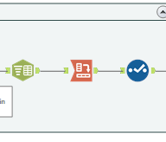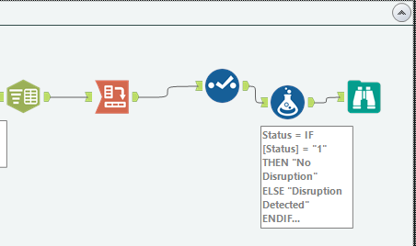
- Text to Columns Tool
A Text to Columns tool then splits the JSON_Name field using a period (.) as the delimiter. This breaks the JSON paths into parts, making it easier to target fields like bus stop description or train alert status.
- Cross Tab Tool
A Cross Tab tool is used to pivot the data. It groups rows by a unique key and sets the final part of the split name as column headers, and fills values using the JSON_ValueString field. This restructures the data into a readable, wide format.
- Select Tool
Finally, a Select tool keeps only the key fields removes extra columns, and arranges them neatly for reporting or dashboard display.
- Formula Tool (for Train Service only)
A Formula tool interprets the Status value: '1' becomes 'No Disruption', otherwise 'Disruption Detected'. This makes the alert easier to understand. If ‘Disruption Detected’, there will also be a message and state which line is disrupted.

- Browse Tool
Browse Tool helps to shows output.

Output:
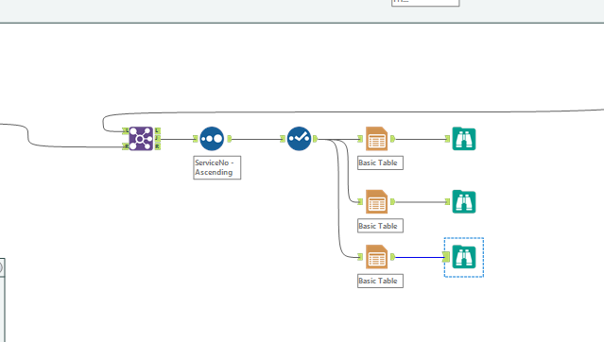
- Join Tool
This step uses the Join tool to combine real-time bus arrival data with static bus stop metadata. The join is configured to match records from the left (containing live arrival info) and the right (containing bus stop descriptions) based on the Bus Stop Code field. By linking these two datasets, the resulting output contains both dynamic details and contextual information.
- Sort Tool
Then, use the Sort tool to sort the order to ascending bus stop.
- Select Tool
In this step, use the Select Tool to remove unnecessary field such as Bus stop code and show the final output.
- Table
In this table, it displays the information of the first, second and third bus separately.
- Browse Tool
Browse Tool helps to shows output.

5.Enhancement
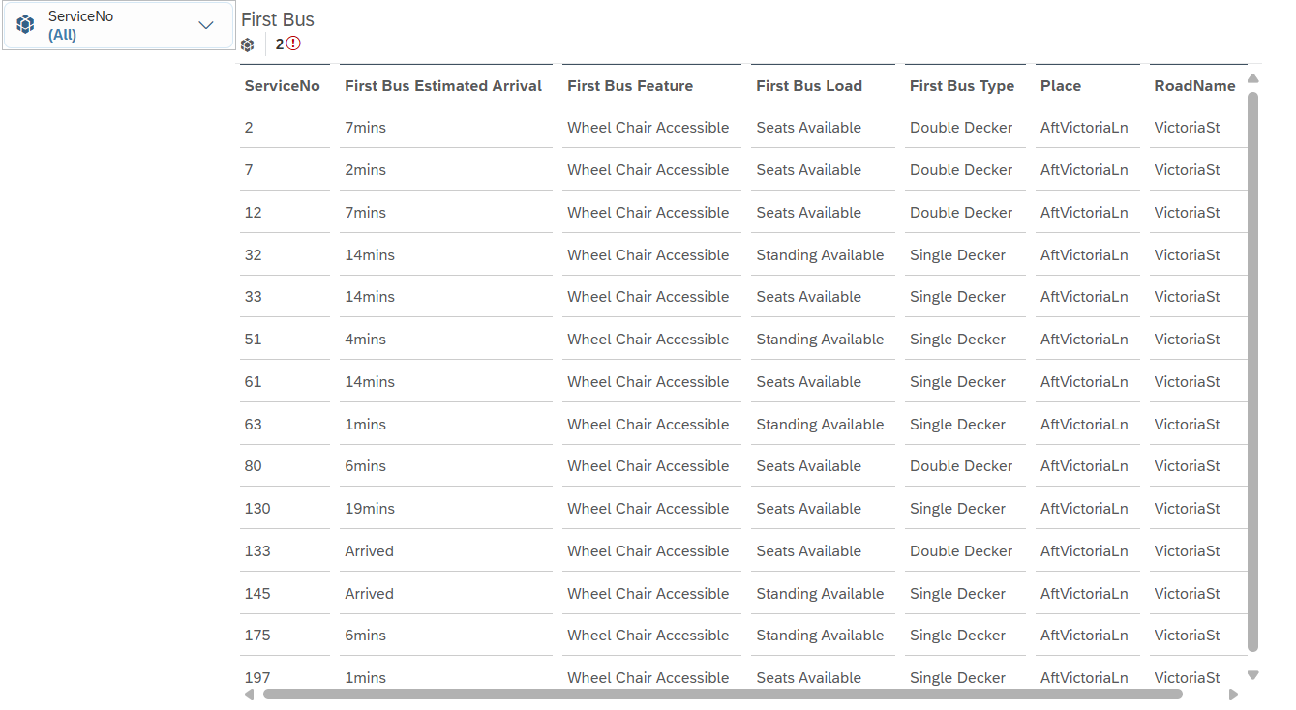
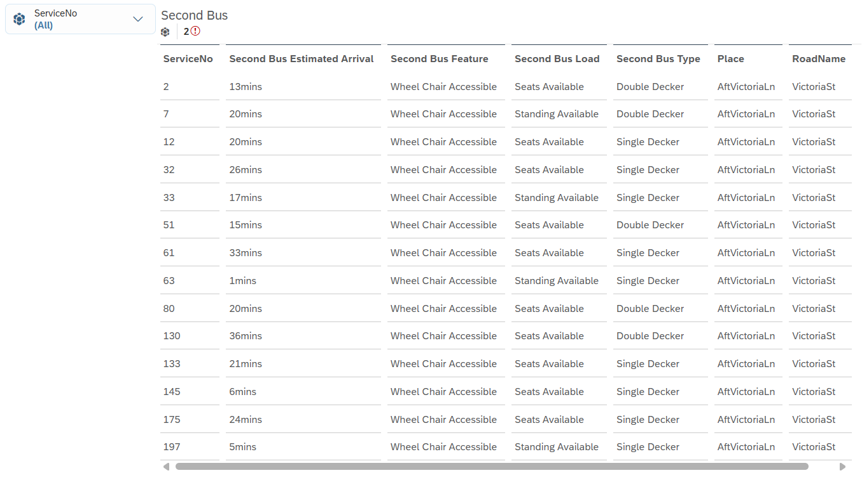

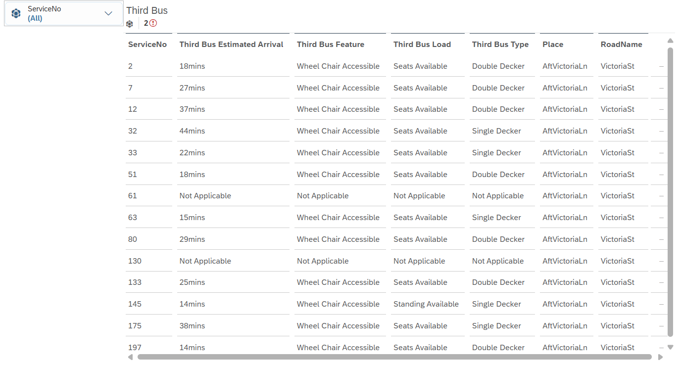

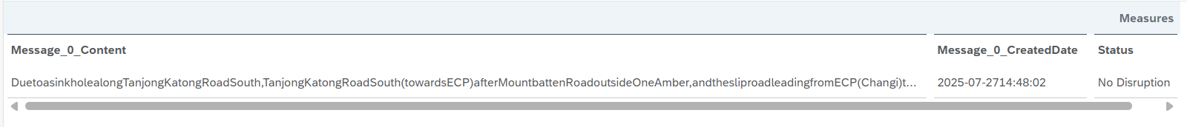
The front end design was done on SAP Analytic Cloud. I exported the data using the Output Tool.I then converted the data into an excel file and uploaded it into SAC. The objective was to provide commuters, transport operators, or analysts with an accessible and informative overview of bus services at the bus code 01121. This interface has a user-friendly design and offers a highly structured and interactive way to track upcoming bus arrivals, passenger loads, accessibility features, and service disruptions. By combining data with user-friendly visuals, it enhances decision-making for both the public and back-end operations teams.
The first 3 tables provides details of arriving buses. Each row displays a service number along with the estimated arrival time for the next three buses. Important features like wheelchair accessibility , seat availability , and bus types are clearly indicated. This allows users to anticipate crowd levels, choose a more comfortable bus, or select services that meet specific needs . For example, wheelchair users can wait for bus with the WAB so that the bus is accessible to them.
Next there is the following metadata such as bus types for the second and third arrivals, place names, and road names. These details allow the users to have a understanding of traffic flow and can be used to enhance route planning and operational logistics.
The presence of a message feed at the bottom provides a real-time status update on any service disruption. In this screenshot, the latest message indicates “No Disruption” and shows the path affected if there had been a change. This is essential for users to respond quickly to incidents. The message content tells the users the road segments and areas affected.
The thing that makes this interface very effective is its interactivity and clarity. There is a filter ( the service number dropdown at the top) allow users to quickly zoom into a specific bus service. This customization is crucial for usability, especially during peak hours when multiple services may arrive within minutes.
In conclusion, the SAP Analytics Cloud dashboard designed for bus stop 01121 shows how real-time transport data can be made accessible and clear. It enhances not only provides more commuter convenience but also operational efficiency. I feel that the kids from the nearby Victoria Primary School would have an easier time to navigate around the interface because the interface only shows the important details of the incoming buses and the details about the train service.

6.Summary

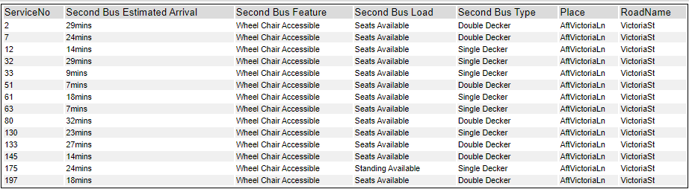
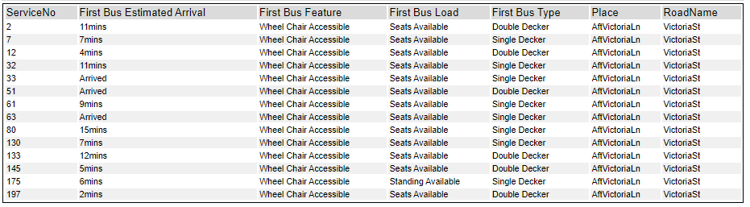
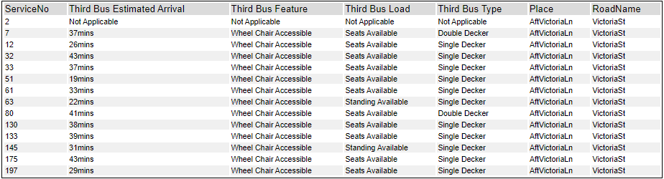
This project was driven by a real-world challenge experienced at bus stop 01121, located outside Victoria primary school. My cousin is a primary school student there and I wish that this solution can benefit him when he travels to and from home. Many students and their parents face uncertainty regarding bus arrival times, which can result in long waits, missed buses, or unnecessary anxiety. Current solutions like SG Buses often fall short due to intrusive ads and cluttered interfaces. Therefore, the goal was to build a real-time bus arrival monitoring system using LTA DataMall APIs to provide clearer, more accessible information.

To achieve this, three APIs were integrated: Bus Arrival, Bus Stop, and Train Service Alert. The Bus Arrival API provided real-time data, filtered and reshaped through tools like JSON Parse, Cross Tab, and Multi-Field Formula to show clean, friendly output such as “Arrived” or “5mins”. The Bus Stop API enriched this by attaching data like road names and descriptions for context. Lastly, the Train Service Alert API offered important MRT status updates, improving the commuter’s overall situational awareness.
Among the tools, I compared different methods for transforming JSON data, such as using individual Formula tools versus the Multi-Field Formula tool. Multi-Field Formula tool proved more efficient for handling multiple fields simultaneously. Example is I did not need to use multiple Formula Tools and instead used the multi-Field Formula tool and ticked the appropriate categories and applied the formula, saving much time and space.
For data presentation, the Cross Tab tool outperformed alternatives like manual reshaping using Transpose, as it allowed quick transformation of repeated service attributes (e.g., “NextBus.Load”, “NextBus.EstimatedArrival”) into columns, simplifying later merging steps.
Lastly, Filter and Select tools were used consistently to streamline data by removing unnecessary fields and focusing on the most meaningful attributes, improving processing speed and clarity.
A key strength of the dataset was its inclusivity, as all services displayed "Wheel Chair Accessible" in the Second Bus Feature column, showing strong accessibility support at bus stop 01121. Additionally, the transformation of short form abbreviations like "DD" and "SD" into clear labels such as "Double Decker" and "Single Decker" made the data more understandable, especially for children and non-technical users. The use of “Not Applicable” as a placeholder for missing or null data further contributed to a smoother user experience, ensuring that dashboards remained visually complete and logically consistent. The inclusion of MRT Train Service Alerts also elevated the final product by providing commuters with a comprehensive multi-modal overview of potential disruptions and service availability.
The end products were tables that clearly shows upcoming buses by service number, their arrival times, and important features such as accessibility (WAB). MRT disruptions were also displayed clearly as either “No Disruption” or “Disruption Detected”. When the “Disruption detected" is displayed, the user check whether their route will be affected and react accordingly.
Throughout the data preparation and analysis stages, several trends and anomalies emerged. A noticeable trend was that Double Decker buses appeared more frequently during off-peak hours and were rarely flagged as “Standing Available,” suggesting that they offer more comfortable rides outside high-demand periods. One anomaly observed was Service 63, which had an estimated arrival time of just 1 minute but was marked as “Standing Available.” This discrepancy may be due to high passenger turnover or slight delays in crowd level updates from the API. Additionally, some API responses contained missing or null values, which were proactively managed using the Multi-Field Formula tool to assign default values like "Not Applicable", ensuring data completeness and avoiding blank fields in the final output. Minor inconsistencies in JSON path structures across APIs also posed challenges, requiring careful handling using the Text to Columns and Cross Tab tools to standardize the dataset format. These findings demonstrate the importance of robust data validation and transformation when working with real-time external data sources.
This solution allows parents and students to make better-informed decisions. With cleaner design, meaningful labels, and consolidated data, it improves on existing apps by reducing complexity and removing unnecessary distractions. The result is a student- and parent-friendly tool that encourages safe, confident commuting.

7.Reflection
One of the biggest improvements I can see for this solution would be to add a mobile-friendly dashboard or app that shows the bus arrival data in real time. Right now, the Alteryx workflow handles the data processing well, but the experience could be much more engaging if users could see visuals like bus icons, countdown timers, or simple journey summaries. Displaying this in Tableau Public or as a responsive web app would make the information easier to understand, especially for younger users like primary school students and their parents. Integrating extra APIs, like MRT crowd levels or weather updates, would also make the solution more useful and responsive to real-world conditions.
From a technical point of view, there is room to optimize the workflow too. I realised I was repeating similar steps, especially when cleaning and parsing JSON from different APIs. There definitely would be more efficient methods which would make this process more efficient and reusable. I also learnt how important it is to handle errors properly. Adding fallback messages like “Not Applicable” or setting up retry logic for failed API calls would make the solution more stable and reduce the need for manual fixes. Another useful upgrade would be to let users input a bus stop code and get a ranked list of nearby bus services with estimated arrival times.
This project really helped me build practical skills in API integration and data wrangling. Before this, I did not have much experience with Alteryx or tools like JSON Parse, Multi-Row Formula, or Cross Tab. I learned how to work with semi-structured data like JSON, extract important fields, and convert messy data into clean tables, allowing for the users to be able to use the information. This gave me a lot more confidence in dealing with real-time data from external sources.
I also improved in planning the logical flow of the workflow. For example, I learned how important it is to check for null fields using filters like IsNull() before applying transformations. Using conditional logic in the Multi-Field Formula tool allowed me to format timestamps into clearer outputs like “3 mins” or “Arrived,” which made the data much easier to understand.
One of the key takeaways for me was learning to align the technical solution with the actual needs of the end users. Even though this was a data project, I kept thinking about how to make it simple and helpful for people, especially young commuters and their families. That is why tools like Select and Filter were so useful. They helped me clean up the data and only show the most relevant info like the service number and when the next bus is arriving.
Going forward, I would love to explore more APIs related to transport, like predicting passenger loads or suggesting alternate routes. These would add real-time adaptability and make the tool even more valuable during busy hours or service disruptions.
Most importantly, this project taught me how to think through the entire process , from getting the data to cleaning and transforming it, all the way to presenting it clearly. It was not just about the data, it was about building something thoughtful and easy to use. That mindset will definitely guide how I work on future projects, especially those that involve public-facing solutions or live data.

